Code Challenge : 4

Time : 60 mts

1. Write a JavaScript program to calculate multiplication and division of two numbers (input from user).

Sample Form:

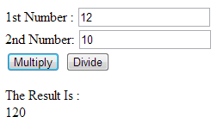

1. Write a JavaScript for loop that will iterate from 0 to 15. For each iteration, it will check if the current number is odd or even, and display a message to the screen.

Sample Output :

"0 is even"  
"1 is odd"  
"2 is even"

1. Write the following application. The initial page is called Validator.aspx and it has 7 text boxes representing (Name, Family Name, Address, City, Zip Code, Phone and e-mail address) and a Check button.

User gets the following page after clicking on Check button:

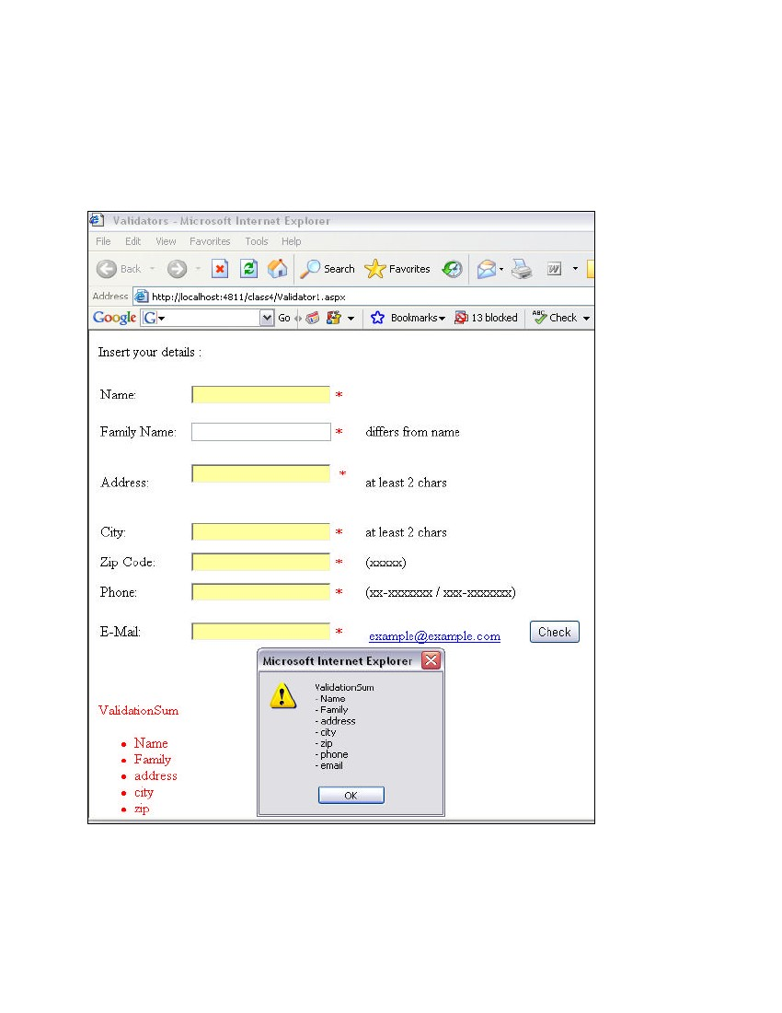

The required validation actions are:

* name different from family name,
* address at least 2 letters,
* city at least 2 letters,
* zip-code 5 digits,
* phone according to the format XX-XXXXXXX or XXX-XXXXXXX,

e-mail is a valid email.